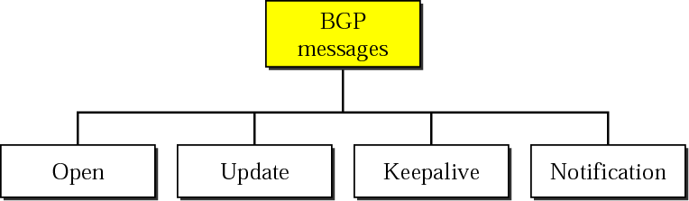

* **OPEN**- Used to open a BGP communication session between peers. This is the first message sent by each side once the 3WHS is complete, and can be thought of as a HELLO. Only once each side has confirmed the OPEN message, the other message types can be exchanged.
* **UPDATE**- Used to exchange routing information, such as announce new routes or withdraw previously announced routes.
* **KEEPALIVE**- Notifies BGP peers that a device is active. Used to keep sessions (i.e long periods with no updates) from expiring.
* **NOTIFICATION**- This message is a result of an error condition occurring. These message types are used to close an active session, and also inform the peer to the reason why.